**Review Worksheet: Fossil Evidence 3 – Fluorine Dating, Phylogenetic Trees.**

Name: ……………………………………

*Do these questions, using your learning resources. Look at the “marks” to give you an idea of the level of detail required in the response (formative only – does not count towards your grade). At the end, mark your work, correct it, and fill in the reflection section. Questions marked * require you to use reasoning, inferring and application of knowledge, or perhaps extra research to get the answer. It won’t be right there in the text.*

1: A range of fossil bones from different species were found in a cave. Describe how fluorine dating works and could be used to determine relative ages of the bones.

(4 marks)

*…………………………………………………………………………………………………………………*

*…………………………………………………………………………………………………………………*

*…………………………………………………………………………………………………………………*

*…………………………………………………………………………………………………………………*

2: Would fluorine dating be useful to determine relative ages of fossils in different locations? Explain your answer.

(3 marks)

*…………………………………………………………………………………………………………………*

*…………………………………………………………………………………………………………………*

*…………………………………………………………………………………………………………………*

3: Based on the phylogenetic tree shown, we can conclude that species 2 is most closely related to species:

(1 mark)

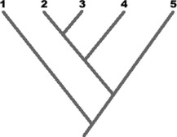 A. 1

B. 3

C. 4

D. 5

E. 1 or 3

4: This tree diagram shows the evolution of land plants as indicated by fossil records.

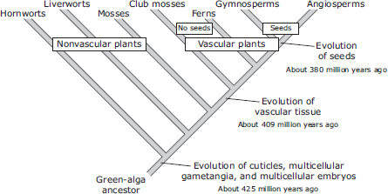

Which discovery would challenge the validity of this diagram?

(1 mark)

1. A large aquatic vascular plant about 200 million years old.
2. A species of algae that has existed for less than one million years.
3. A moss species that has existed for less than 380 million years.
4. A fossil of a fern more than 425 million years old.

5: Use the following characteristics of these organisms to make a tree diagram. Remember that all organisms started with a common ancestor, so all phylogenetic tree diagrams should start from a single point and branch as they develop differing characteristics.

(1 mark)

|  |  |  |  |  |
| --- | --- | --- | --- | --- |
| Characteristics | Shark | Bullfrog | Kangaroo | Human |
| Vertebrae | X | X | X | X |
| Two pairs of  limbs |  | X | X | X |
| Mammary  Glands |  |  | X | X |
| Placenta |  |  |  | X |

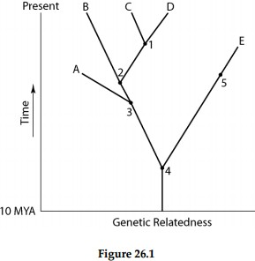6: A common ancestor for both species C and E could be at position number:

(1 mark)

A) 1 B) 2 C) 3 D) 4 E) 5

7: Use the following data table to construct a cladogram of the major plant groups below. The table shows which plants have the traits listed.

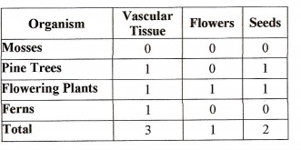 (1 mark)



8: On a hot day, water is lost to the body due to sweating.  
  
Draw an annotated homeostatic feedback loop to show how fluid balance is maintained when water is lost. (15 marks out of 18 possible marks on key)

Go back and mark your work using the marking key provided. What score did you get? /27

*I included enough detail and scientific terminology in my answers.*



*I was able to find information in the text/powerpoint presentation.*

*I was able to reason and infer where the information wasn’t directly in the text (questions with *).*

*I marked my work and wrote down any answers where I missed marks.*